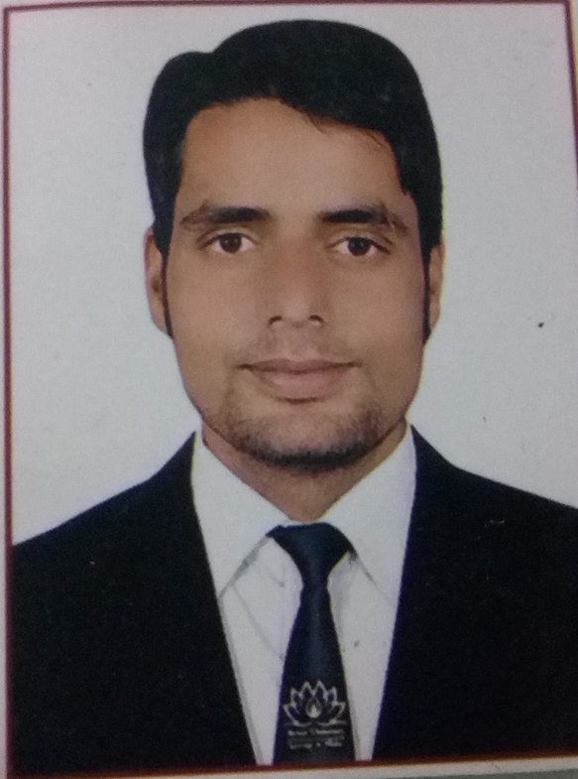
Curriculum Vitae
SUHAIL AHMAD DAR
BARAMULLA, J&K
PHONE: 9149783709
E-mail: suhaild984@gmail.com

Objective
My aim of joining is to utilize my knowledge and skills for the improvement of my professional career along with the growth of the company.
Work Experience
- Organization: Jamkash Vehicleades Pvt. Ltd. (Kashmir)
Duration : 1 Year
Designation: Customer Care Manager
- Six months of work experience from Shanti India Geo Services

Academic Qualification
Course | Institute/ University | Year of passing | Percentage
B Tech (civil) | Mewar University | 2017 | 7.79
XII | JKBOSE | 2012 | 84%
X | JKBOSE | 2010 | 71%

Certifications
- 6 Months internship in Industrial Training
- Diploma in Computer Applications from NDLM
- STAAD pro

Achievements:
- Passed with Distinction in 10+2 and in Engineering.

Hobbies:
- Staying up to date by Surfing the World Wide Web
- Great Passion for Football

Domain of Interests:
- Marketing and Advertising
- Site engineering
- Business Processing Outsourcing

Personal data
Date of Birth: 04th March, 1995
Father’s Name: Ghulam Mohammad
Mothers Name: Late Rafeeqa Begum
Gender: Male
Nationality : Indian
Linguistic Proficiency: English, Kashmiri, Urdu & Hindi
Permanent Address: Wagoora Baramulla, J&K

Declaration
I hear by declare that all the information given above is true and correct to the best of my knowledge
Place: Signature
Date: Suhail Ahmad Dar

